Cancer Registry Module in HIS 4

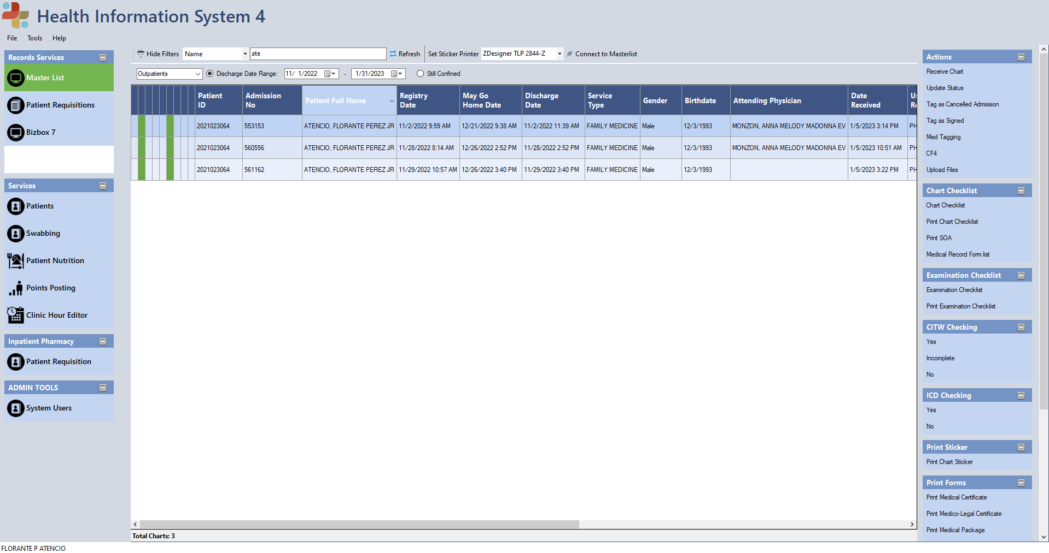After selecting a Patient then click Medical Record Form List

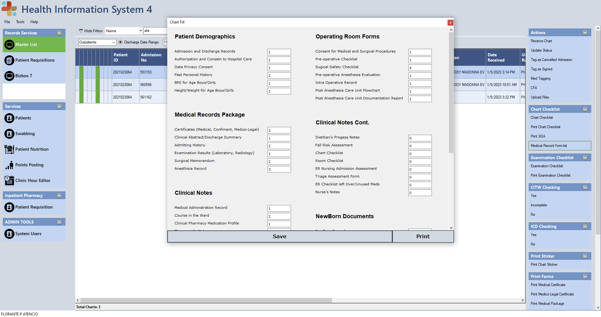Cancer Registry Window will pop up

All Text and Label field will be Dynamically showing Base in Admin (LANZ) Input in his own UI. All Text box leave Blank will Automatically convert to Zero Value. To Save click the Save Button (In case for any changes) Then Click the Print button to print.

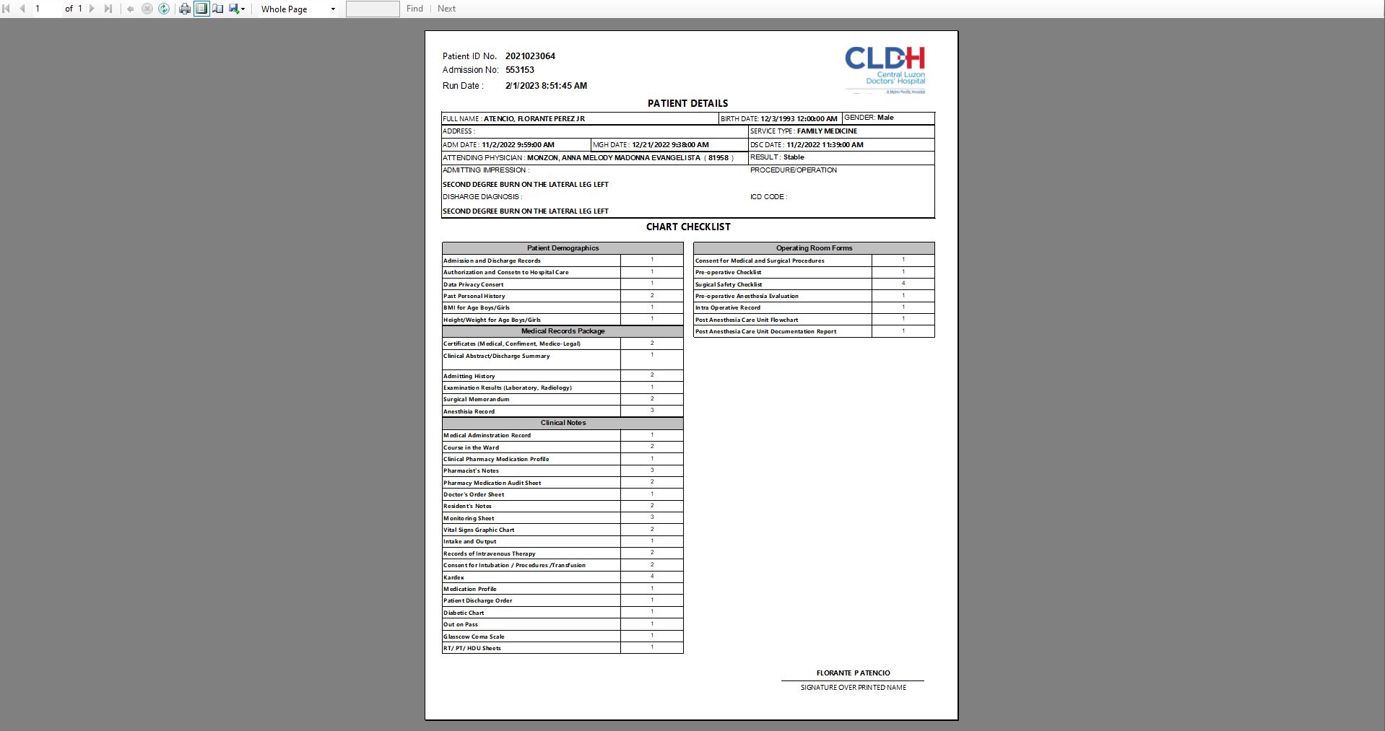Report Viewer Will pop up after clicking print button. Accessing Report server 10.4.1.3/reportserver/JUN/frmMedicalRecord.rdl

ADMIN SIDE (LANZ)

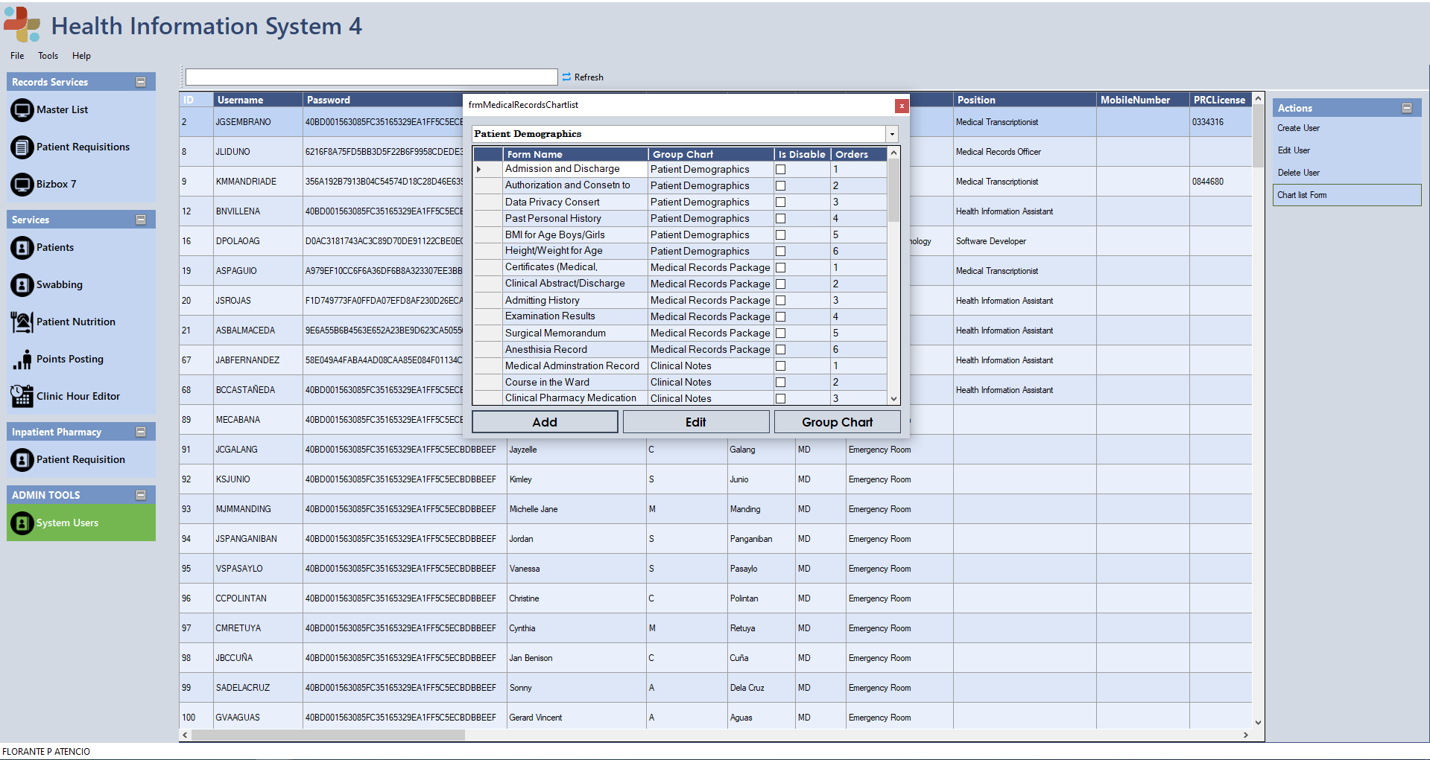

Under Module ADMIN TOOLS (System Users) Under Action Tab (Chartlist Form), frmMedicalRecordsChartlist window will pop up. It can add or edit Chartlist Form, Form can be disable, and set orders.

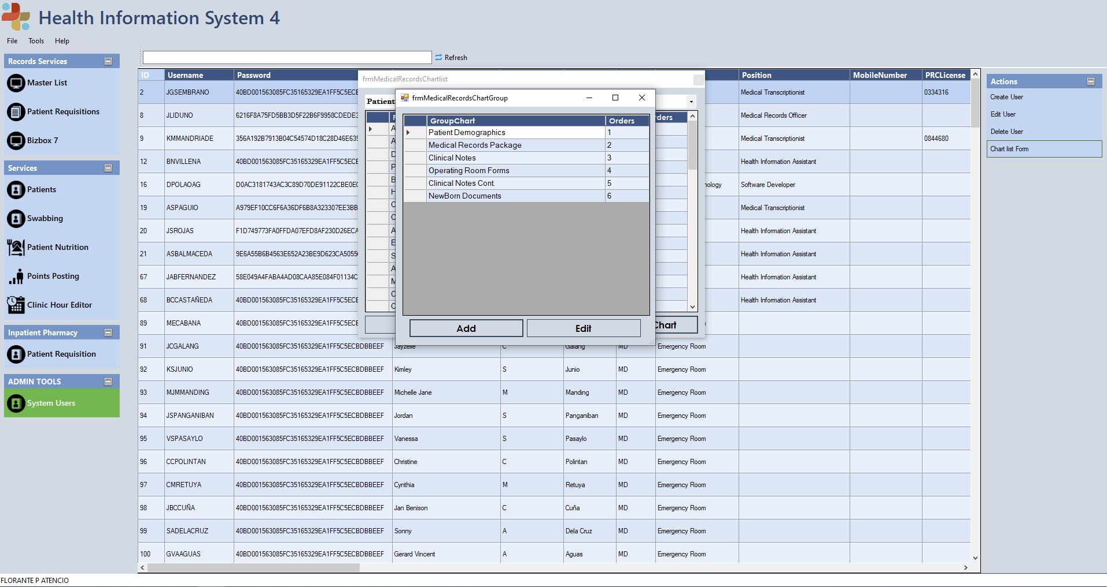It can add Another GroupChart Form just click “Group Chart Button” then it can add or edit Group chart, and set orders.

**ADO.NET (Table Adapter and DataBindsource)**

Accessing 10.4.1.3/sqlcldh02 (HealthInfoDB) and 10.4.1.3/sqlcldh01 (LIVE_CLDH)

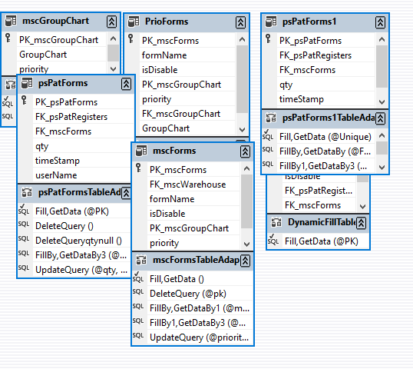

**Demo Graphics**

**PSPATFORMS**

**PRIOFORM**

**DYNAMICFILL**

**CRUD**

**MSCGROUPCHART**

**MSCFORMS**

**PSPATFORMS1**

**Module Source Code**

**SQL SERVER:**

use HealthInfoDB;

drop table mscForms;

CREATE TABLE mscForms(

[PK_mscForms] [int] IDENTITY(1,1) primary key,

[FK_mscWarehouse] [int] NULL,

[formName] [nvarchar](max) NULL,

[isDisable] bit default 1

)

use HealthInfoDB;

DROP TABLE IF EXISTS psPatForms;

Create table psPatForms(

PK_psPatForms INT IDENTITY (1,1) PRIMARY KEY,

FK_psPatRegisters INT,

FK_mscForms INT,

qty INT,

timeStamp DATETIME DEFAULT GETDATE(),

FK_user INT

);

USE HealthInfoDB;

DROP TABLE IF EXISTS mscGroupChart;

CREATE TABLE mscGroupChart(

PK_mscGroupChart INT PRIMARY KEY IDENTITY(1,1),

GroupChart NVARCHAR(MAX)

);

USE [HealthInfoDB]

GO

CREATE TABLE [dbo].[Usertbl](

[ID] [int] IDENTITY(300,1) NOT NULL,

[Username] [varchar](50) NOT NULL,

[Password] [varchar](50) NOT NULL,

[Firstname] [varchar](50) NULL,

[Middlename] [varchar](50) NULL,

[Lastname] [varchar](50) NULL,

[Suffix] [varchar](50) NULL,

[Department] [varchar](50) NULL,

[Position] [varchar](50) NULL,

[MobileNumber] [varchar](50) NULL,

[PRCLicense] [varchar](50) NULL,

[mrdservices] [bit] NULL,

[mrdserviceswrite] [bit] NULL,

[mrdothers] [bit] NULL,

[nsoservices] [bit] NULL,

[clinpharm] [bit] NULL,

[emergencyroom] [bit] NULL,

[opdservices] [bit] NULL,

[admin] [bit] NULL,

[admitting] [bit] NULL,

[wellnesscard] [bit] NULL,

[FK_mscWarehouse] [varchar](50) NULL,

[FK_mscPositions] [varchar](50) NULL,

[FK_mscNrstation] [varchar](50) NULL,

[inpatient] [bit] NULL,

[outpatient] [bit] NULL,

[er] [bit] NULL,

[pdo] [bit] NULL,

[antimicrobial] [bit] NULL,

[cf4] [bit] NULL,

[admittingforms] [bit] NULL,

[dataprivacy] [bit] NULL,

[medtagging] [bit] NULL,

[animalbite] [bit] NULL,

[medcert] [bit] NULL,

[coc] [bit] NULL,

[biz7read] [bit] NULL,

[biz7write] [bit] NULL,

[oldchart] [bit] NULL,

[doctorsorder] [bit] NULL,

[cribtag] [bit] NULL,

[cif] [bit] NULL,

[covid19mortality] [bit] NULL,

[nutrition] [bit] NULL,

[nutritionscreening] [bit] NULL,

[privilegepoints] [bit] NULL,

[clinichours] [bit] NULL,

[cumulativelab] [bit] NULL,

[ersuturing] [bit] NULL,

[hduform] [bit] NULL,

[cancerregistryform] [bit] NULL,

[ambulancelog] [bit] NULL,

[ifcinsertion] [bit] NULL,

[endotrachealIntubation] [bit] NULL,

[orlogbook] [bit] NULL,

[paculogbook] [bit] NULL,

[formdemographics] [bit] NULL,

[antimicrobialres] [bit] NULL,

)

**Visual Studio 2019 C#**

**frmMedicalFillForms Class:**

namespace HealthInformationSystem4.Forms

{

public partial class frmMedicalFillForms : Form

{

public string pk { get; set; }

public string pk2;

List<TextBox> text = new List<TextBox>();

List<Label> forms = new List<Label>();

void dynamicForm()

{

CancerRegistryTableAdapters.mscFormsTableAdapter msc = new CancerRegistryTableAdapters.mscFormsTableAdapter();

CancerRegistryTableAdapters.mscGroupChartTableAdapter group = new CancerRegistryTableAdapters.mscGroupChartTableAdapter();

CancerRegistryTableAdapters.psPatFormsTableAdapter pats = new CancerRegistryTableAdapters.psPatFormsTableAdapter();

CancerRegistry mscPats = new CancerRegistry();

CancerRegistry msccan = new CancerRegistry();

CancerRegistry groupcan = new CancerRegistry();

int x = 20 , y = 20;

panel2.Controls.Clear();

text.Clear();

forms.Clear();

group.Fill(groupcan.mscGroupChart);

double sub = groupcan.mscGroupChart.Rows.Count / 2;

double sub2 = Math.Round(sub);

for (int i = 0; i < groupcan.mscGroupChart.Rows.Count; i++)

{

Label lab = new Label();

lab.Text = groupcan.mscGroupChart[i]["GroupChart"].ToString();

lab.Size = new Size(300, 20);

lab.Location = new Point(x , y);

lab.Font = new Font("Arial", 13 , FontStyle.Bold);

panel2.Controls.Add(lab);

y += 50;

msc.FillBy1(msccan.mscForms, int.Parse(groupcan.mscGroupChart[i]["PK_mscGroupChart"].ToString()));

for (int u = 0; u < msccan.mscForms.Rows.Count; u++)

{

TextBox Box = new TextBox();

Label form = new Label();

Label mscpk = new Label();

form.Size = new Size(300, 20);

form.Location = new Point(x , y);

form.Text = msccan.mscForms[u]["formName"].ToString();

pats.FillBy(mscPats.psPatForms, int.Parse(pk),int.Parse(msccan.mscForms[u]["PK_mscForms"].ToString()));

if (mscPats.psPatForms.Rows.Count > 0)

{

Box.Location = new Point(x + 300, y);

Box.Size = new Size(75, 20);

Box.Text = mscPats.psPatForms[0]["qty"].ToString();

}

else

{

Box.Location = new Point(x + 300, y);

Box.Size = new Size(75, 20);

}

mscpk.Text = msccan.mscForms[u]["PK_mscForms"].ToString();

text.Add(Box);

forms.Add(mscpk);

panel2.Controls.Add(form);

panel2.Controls.Add(Box);

y += 25;

}

y += 50;

if ( (i+1) % sub2 == 0 )

{

x += 450;

y = 20;

}

}

panel2.Show();

}

public frmMedicalFillForms()

{

InitializeComponent();

}

// ----------------------- FORMS LOAD -----------------------//

private void frmMedicalFillForms_Load(object sender, EventArgs e)

{

//// TODO: This line of code loads data into the 'cancerRegistry1.mscWarehouse1' table. You can move, or remove it, as needed.

//this.mscWarehouse1TableAdapter.Fill(this.cancerRegistry.mscWarehouse1);

//// TODO: This line of code loads data into the 'cancerRegistry.mscWarehouse1' table. You can move, or remove it, as needed.

//this.psPatFormsTableAdapter.Fill(this.cancerRegistry.psPatForms, int.Parse(pk));

//this.mscWarehouse2TableAdapter.Fill(this.cancerRegistry.mscWarehouse2, int.Parse(pk));

//this.mscWarehouse2BindingSource.Filter = "qty > 0";

dynamicForm();

}

// ----------------------- Adding Button -----------------------//

private void addButton_Click(object sender, EventArgs e)

{

//------------------- Declaration Variables -----------------------//

//frmMedicalFillFormsAddEdit form = new frmMedicalFillFormsAddEdit();

//form.fk_psPatRegistsr = pk;

//form.addoredit = 1;

////------------------- show dialog -----------------------//

//form.ShowDialog();

//this.mscWarehouse2TableAdapter.Fill(this.cancerRegistry.mscWarehouse2, int.Parse(pk));

//this.Refresh();

}

// ----------------------- Edit Button -----------------------//

private void editButton_Click_1(object sender, EventArgs e)

{

//// ----------------------- Checking for data -----------------------//

//if (dataGridView1.Rows.Count > 0)

//{

// //------------------- Declaration Variables -----------------------//

// CancerRegistryTableAdapters.psPatForms1TableAdapter medred = new CancerRegistryTableAdapters.psPatForms1TableAdapter();

// CancerRegistry cancer = new CancerRegistry();

// // ----------------------- Checking for PS_patRegisters if exists -----------------------//

// medred.Fill(cancer.psPatForms1, int.Parse(dataGridView1.CurrentRow.Cells[1].Value.ToString()));

// if (cancer.psPatForms1.Rows.Count > 0)

// {

// frmMedicalFillFormsAddEdit form = new frmMedicalFillFormsAddEdit();

// form.pk_psPatForms = dataGridView1.CurrentRow.Cells[0].Value.ToString();

// form.fk_psPatRegistsr = pk;

// form.mscforms = dataGridView1.CurrentRow.Cells[2].Value.ToString();

// form.addoredit = 2;

// form.ShowDialog();

// }

//}

//else {

// MessageBox.Show("Failed! Please input data first.");

//}

////------------------- show dialog -----------------------//

//this.mscWarehouse2TableAdapter.Fill(this.cancerRegistry.mscWarehouse2, int.Parse(pk));

//this.Refresh();

}

// ----------------------- Print Button -----------------------//

private void printButton_Click(object sender, EventArgs e)

{

// frmMedicalRecordsReports reports = new frmMedicalRecordsReports();

// reports.pk_psPatRegisters = pk;

// reports.ShowDialog();

}

private void button1_Click(object sender, EventArgs e)

{

//frmDynamicFIllFormAdd dyanamic = new frmDynamicFIllFormAdd();

//dyanamic.Pk_psPatRegisters = pk;

//dyanamic.ShowDialog();

//this.mscWarehouse2TableAdapter.Fill(this.cancerRegistry.mscWarehouse2, int.Parse(pk));

//this.Refresh();

}

private void button2_Click(object sender, EventArgs e)

{

//frmDynamicEditForm edit = new frmDynamicEditForm();

//edit.Pk_psPatRegisters = pk;

//edit.ShowDialog();

//this.mscWarehouse2TableAdapter.Fill(this.cancerRegistry.mscWarehouse2, int.Parse(pk));

//this.Refresh();

}

private void button1_Click_1(object sender, EventArgs e)

{

int count = 0;

CancerRegistryTableAdapters.psPatFormsTableAdapter pat = new CancerRegistryTableAdapters.psPatFormsTableAdapter();

CancerRegistryTableAdapters.psPatFormsTableAdapter pats = new CancerRegistryTableAdapters.psPatFormsTableAdapter();

CancerRegistry mscPats = new CancerRegistry();

pats.Fill(mscPats.psPatForms, int.Parse(pk));

if (mscPats.psPatForms.Rows.Count > 0)

{

foreach (var items in text)

{

if (items.Text == "")

{

pat.Insert(int.Parse(pk), int.Parse(forms[count].Text), 0 , DateTime.Now, Properties.Settings.Default.loggedID);

count++;

}

else

{

pats.UpdateQuery(int.Parse(items.Text), int.Parse(pk), int.Parse(forms[count].Text));

count++;

}

}

foreach (var item in text)

{

item.Text = item.Text == "" ? "0" : item.Text;

}

}

else

{

foreach (var item in text)

{

item.Text = item.Text == "" ? "0" : item.Text;

}

foreach (var texts in text)

{

pat.Insert(int.Parse(pk), int.Parse(forms[count].Text), int.Parse(texts.Text), DateTime.Now, Properties.Settings.Default.loggedID);

count++;

}

}

}

private void button2_Click_1(object sender, EventArgs e)

{

frmMedicalRecordsReports reports = new frmMedicalRecordsReports();

reports.pk_psPatRegisters = pk;

reports.ShowDialog();

}

**frmMedicalRecordsChartlist:**

namespace HealthInformationSystem4.Forms

{

public partial class frmMedicalRecordsChartlist : Form

{

public frmMedicalRecordsChartlist()

{

InitializeComponent();

}

private void frmMedicalRecordsChartlist_Load(object sender, EventArgs e)

{

// TODO: This line of code loads data into the 'cancerRegistry.PrioForms' table. You can move, or remove it, as needed.

this.prioFormsTableAdapter.Fill(this.cancerRegistry.PrioForms);

// TODO: This line of code loads data into the 'cancerRegistry.mscGroupChart' table. You can move, or remove it, as needed.

this.mscGroupChartTableAdapter.Fill(this.cancerRegistry.mscGroupChart);

//------------------- Deleting all "" values -----------------------//

//foreach (DataGridViewRow R in dataGridView1.Rows)

//{

// if (R.Cells[0].Value.ToString() == "")

// {

// this.mscFormsTableAdapter.DeleteQuery(R.Cells[0].Value.ToString());

// this.mscFormsTableAdapter.Fill(this.cancerRegistry.mscForms);

// }

//}

}

//-------------------Department fill ComboBox -----------------------//

private void fK_mscWarehouseComboBox_SelectedIndexChanged(object sender, EventArgs e)

{

try

{

this.prioFormsBindingSource.Filter = "GroupChart = '" + fK_mscWarehouseComboBox.Text + "'";

this.prioFormsTableAdapter.Fill(this.cancerRegistry.PrioForms);

//string a = fK_mscWarehouseComboBox.SelectedValue.ToString();

//this.mscFormsBindingSource.Filter = "FK_mscWarehouse = " + a;

//this.mscFormsTableAdapter.Fill(this.cancerRegistry.mscForms);

}

catch (System.Exception ex)

{

MessageBox.Show("Something went wrong " + ex);

}

}

//------------------- Add Button -----------------------//

private void addButtonShow_Click(object sender, EventArgs e)

{

//------------------- Add Entry -----------------------//

//CancerRegistryTableAdapters.mscFormsTableAdapter form = new CancerRegistryTableAdapters.mscFormsTableAdapter();

//form.Insert(null, null, 0, null);

//------------------- counter -----------------------//

frmMedicalRecordsChartlistAddEdit update = new frmMedicalRecordsChartlistAddEdit();

update.indication = 0;

update.pk = "";

update.ShowDialog();

this.prioFormsTableAdapter.Fill(this.cancerRegistry.PrioForms);

//------------------- Remove space data -----------------------//

//foreach (DataGridViewRow R in dataGridView1.Rows)

//{

// if (R.Cells[0].Value.ToString() == "")

// {

// this.mscFormsTableAdapter.DeleteQuery(R.Cells[0].Value.ToString());

// this.mscFormsTableAdapter.Fill(this.cancerRegistry.mscForms);

// }

//}

//------------------- Refresh -----------------------//

//this.mscFormsTableAdapter.Fill(this.cancerRegistry.mscForms);

//this.Refresh();

}

private void editButtonShow_Click(object sender, EventArgs e)

{

//------------------- Check value if 0 count -----------------------//

if (dataGridView1.Rows.Count > 0)

{

//------------------- Update the Data Selected -----------------------//

CancerRegistryTableAdapters.mscFormsTableAdapter form = new CancerRegistryTableAdapters.mscFormsTableAdapter();

CancerRegistry data = new CancerRegistry();

form.Fill(data.mscForms);

if (data.mscForms.Rows.Count > 0)

{

frmMedicalRecordsChartlistAddEdit update = new frmMedicalRecordsChartlistAddEdit();

update.pk = dataGridView1.CurrentRow.Cells[0].Value.ToString();

update.indication = 1;

update.ShowDialog();

}

}

else {

MessageBox.Show("Input data first!");

}

//------------------- Refresh -----------------------//

this.prioFormsTableAdapter.Fill(this.cancerRegistry.PrioForms);

//this.mscFormsTableAdapter.Fill(this.cancerRegistry.mscForms);

this.Refresh();

}

private void dataGridView1_CellContentClick_1(object sender, DataGridViewCellEventArgs e)

{

}

private void button1_Click(object sender, EventArgs e)

{

frmMedicalRecordsChartGroup group = new frmMedicalRecordsChartGroup();

group.ShowDialog();

this.mscGroupChartTableAdapter.Fill(this.cancerRegistry.mscGroupChart);

}

private void button2_Click(object sender, EventArgs e)

{

frmMedicalRecordsDynamicArrange arrange = new frmMedicalRecordsDynamicArrange();

arrange.ShowDialog();

}}}

**frmMedicalRecordsChartlistaddoredit:**

namespace HealthInformationSystem4.Forms

{

public partial class frmMedicalRecordsChartlistAddEdit : Form

{

public string pk { get; set; }

public int indication { get; set; }

public frmMedicalRecordsChartlistAddEdit( )

{

InitializeComponent();

}

private void frmMedicalRecordsChartlistAddEdit_Load(object sender, EventArgs e)

{

// TODO: This line of code loads data into the 'cancerRegistry.mscForms' table. You can move, or remove it, as needed.

//this.mscFormsTableAdapter.Fill(this.cancerRegistry.mscForms);

// TODO: This line of code loads data into the 'cancerRegistry.mscGroupChart' table. You can move, or remove it, as needed.

this.mscGroupChartTableAdapter.Fill(this.cancerRegistry.mscGroupChart);

// TODO: This line of code loads data into the 'cancerRegistry.mscWarehouse' table. You can move, or remove it, as needed.

//this.mscWarehouseTableAdapter.Fill(this.cancerRegistry.mscWarehouse);

if (indication == 1)

{

this.mscFormsTableAdapter.FillBy(this.cancerRegistry.mscForms, int.Parse(pk));

}

else { }

}

// ------------------------ Update button-----------------------------//

private void button1_Click(object sender, EventArgs e)

{

if (indication != 1)

{

try

{

mscFormsTableAdapter.Insert(formNameTextBox.Text, isDisableCheckBox.Checked, int.Parse(fK_mscWarehouseComboBox.SelectedValue.ToString()), int.Parse(numericUpDown1.Value.ToString()));

MessageBox.Show("Succesful","Fuck You");

}

catch

{

MessageBox.Show("Failed to Add","Warning!");

}

}

else

{

try

{

this.mscFormsBindingSource.EndEdit();

this.mscFormsTableAdapter.Update(this.cancerRegistry.mscForms);

MessageBox.Show("Success!");

this.Close();

}

catch (System.Exception ex)

{

MessageBox.Show("Failed to Updated " + ex);

}}}}}

frmMedicalRecordChartGroup Class:

namespace HealthInformationSystem4.Forms

{

public partial class frmMedicalRecordsChartGroup : Form

{

public frmMedicalRecordsChartGroup()

{

InitializeComponent();

}

private void frmMedicalRecordsChartGroup_Load(object sender, EventArgs e)

{

// TODO: This line of code loads data into the 'cancerRegistry.mscGroupChart' table. You can move, or remove it, as needed.

this.mscGroupChartTableAdapter.Fill(this.cancerRegistry.mscGroupChart);

// TODO: This line of code loads data into the 'cancerRegistry.mscGroupChart' table. You can move, or remove it, as needed.

this.mscGroupChartTableAdapter.Fill(this.cancerRegistry.mscGroupChart);

}

private void addButtonShow_Click(object sender, EventArgs e)

{

frmMedicalRecordsChartGroupAddEdit add = new frmMedicalRecordsChartGroupAddEdit();

add.PK_mscGroupChart = 0;

add.ShowDialog();

this.mscGroupChartTableAdapter.Fill(this.cancerRegistry.mscGroupChart);

}

private void editButtonShow_Click(object sender, EventArgs e)

{

CancerRegistryTableAdapters.mscGroupChartTableAdapter group = new CancerRegistryTableAdapters.mscGroupChartTableAdapter();

CancerRegistry can = new CancerRegistry();

group.Fill(can.mscGroupChart);

if (can.mscGroupChart.Rows.Count > 0)

{

frmMedicalRecordsChartGroupAddEdit edit = new frmMedicalRecordsChartGroupAddEdit();

edit.PK_mscGroupChart = int.Parse(dataGridView1.CurrentRow.Cells[0].Value.ToString());

edit.ShowDialog();

this.mscGroupChartTableAdapter.Fill(this.cancerRegistry.mscGroupChart);

}

else

{

MessageBox.Show("No Entry Found", "Empty Table");

}}}}

frmMedicalRecordsChartGroupaddoredit class:

namespace HealthInformationSystem4.Forms

{

public partial class frmMedicalRecordsChartGroupAddEdit : Form

{

public frmMedicalRecordsChartGroupAddEdit()

{

InitializeComponent();

}

public int PK_mscGroupChart { get; set; }

private void frmMedicalRecordsChartGroupAddEdit_Load(object sender, EventArgs e)

{

// TODO: This line of code loads data into the 'cancerRegistry.mscGroupChart' table. You can move, or remove it, as needed.

//this.mscGroupChartTableAdapter.Fill(this.cancerRegistry.mscGroupChart);

if (PK_mscGroupChart > 0)

{

this.mscGroupChartTableAdapter.FillBy(this.cancerRegistry.mscGroupChart, PK_mscGroupChart);

}

}

private void button1_Click(object sender, EventArgs e)

{

if (PK_mscGroupChart > 0)

{

try

{

this.mscGroupChartBindingSource.EndEdit();

this.mscGroupChartTableAdapter.Update(cancerRegistry.mscGroupChart);

MessageBox.Show("Success!");

this.Close();

}

catch (Exception ex)

{

MessageBox.Show(" Something Went Wrong " + ex);

}

}

else

{

try

{

this.mscGroupChartTableAdapter.Insert(formNameTextBox.Text, int.Parse(priorityNumericUpDown.Value.ToString()));

MessageBox.Show("Succesful", "Fuck You");

}

catch (System.Exception ex)

{

MessageBox.Show(" Something Went Wrong " + ex);

}

} } }

Report Viewer :

Dataset1

SELECT d.patid,a.registryno,b.fullname,c.cpaddress,c.birthdate,c.gender,a.registrydate,a.mghdatetime,a.dischdate,a.dischdiagnosis,a.surgicalproc,a.FK_mscServiceType,g.description as ServiceType,a.finaldiagnosis,a.finaldiagcode,a.impression,a.FK_mscAdmResults,f.description as AdmResult,a.pattrantype,e.prcno,dbo.udf_GetFullName(e.PK_emdDoctors) AS attendingPhysician FROM psPatRegisters a left JOIN psDatacenter b ON a.FK_emdPatients = b.PK_psDatacenter left JOIn psPersonaldata c ON c.PK_psPersonalData = a.FK_emdPatients left JOIN emdPatients d On d.PK_emdPatients = a.FK_emdPatients

left JOIN emdDoctors e

ON e.PK_emdDoctors = dbo.udf_GetAttendingDoctorsID(a.PK_psPatRegisters)

left JOIN mscAdmResults f

ON f.PK_mscAdmResults = a.FK_mscAdmResults

left JOIN mscServiceType g

ON g.PK_mscServiceType = a.FK_mscServiceType

WHERE a.PK_psPatRegisters = @PK

Dataset3 :

SELECT TOP 1

k.Lastname,

k.Firstname,

k.Middlename

FROM psPatRegisters a

JOIN [10.4.1.3\sqlcldh02].HealthInfoDB.dbo.psPatForms h

ON a.PK_psPatRegisters = h.FK_psPatRegisters

JOIN [10.4.1.3\sqlcldh02].HealthInfoDB.dbo.mscForms j

ON j.PK_mscForms = h.FK_mscForms

JOIN [10.4.1.3\sqlcldh02].HealthInfoDB.dbo.Usertbl k

ON k.Username = h.userName

WHERE a.PK_psPatRegisters = @PK

Dateset 2:

SELECT

a.PK_mscGroupChart

,a.GroupChart

,a.priority as GroupPriority

,b.FK_mscGroupChart

,b.formName

,b.isDisable

,b.PK_mscForms

,b.priority as FormPriority

,c.userName

,c.qty as FormQuantity

,c.FK_psPatRegisters

,c.PK_psPatForms

,c.FK_mscForms

,c.timeStamp

FROM [10.4.1.3\sqlcldh02].[HealthInfoDB].[dbo].[mscGroupChart] a

JOIN [10.4.1.3\sqlcldh02].[HealthInfoDB].[dbo].[mscForms] b

ON a.PK_mscGroupChart= b.FK_mscGroupChart

JOIN [10.4.1.3\sqlcldh02].[HealthInfoDB].[dbo].psPatForms c

ON c.FK_mscForms = b.PK_mscForms

Where a.priority <= (select round( max(z.priority)/2, 0 ) FROM [10.4.1.3\sqlcldh02].[HealthInfoDB].[dbo].[mscGroupChart] z )

AND c.FK_psPatRegisters = @PK

Dataset 2:

SELECT

a.PK_mscGroupChart

,a.GroupChart

,a.priority as GroupPriority

,b.FK_mscGroupChart

,b.formName

,b.isDisable

,b.PK_mscForms

,b.priority as FormPriority

,c.userName

,c.qty as FormQuantity

,c.FK_psPatRegisters

,c.PK_psPatForms

,c.FK_mscForms

,c.timeStamp

FROM [10.4.1.3\sqlcldh02].[HealthInfoDB].[dbo].[mscGroupChart] a

JOIN [10.4.1.3\sqlcldh02].[HealthInfoDB].[dbo].[mscForms] b

ON a.PK_mscGroupChart= b.FK_mscGroupChart

JOIN [10.4.1.3\sqlcldh02].[HealthInfoDB].[dbo].psPatForms c

ON c.FK_mscForms = b.PK_mscForms

Where a.priority > (select round( max(z.priority)/2, 0 ) FROM [10.4.1.3\sqlcldh02].[HealthInfoDB].[dbo].[mscGroupChart] z )

AND c.FK_psPatRegisters = @PK

